Next Sunday – 25th August 10th Sunday after Trinity

Sunday Eucharists – Prayer and healing ministry is now routinely available during Communion at the back of the church

Talent Auction - Today!

Fundraising
St. Andrew's 'Blessings Box' is now in operation.
Take a box home, consume the contents, fill with coins, bring back to church for Gail, who will then empty it, refill with jelly beans, and return it to you!

Cake Walk
Saturday 31st August
Jane is organising a cake walk as a fundraiser.
We will meet in the hall at 11am, walk 5-6 miles and return to the hall for tea and cake. If you would like to take part but not do the walk just turn up for the tea!
Donations gratefully received for this event.

Favourite Hymn Requests
There is a list at the back of the church for your favourite hymns.
So far, we have only two such requests!
Please feel free to add some more – the organist is very keen to hear from you!

PLEASE PASS INFORMATION FOR NOTICES TO Andrea BY THE THURSDAY OF ANY WEEk
Tel: 0141 942 0029 Email: andreahagenbuch@outlook.com

St Andrew’s  Scottish Episcopal Church,  Park Road, Milngavie  Sunday 18th August  Ninth Sunday after Trinity |  |  | 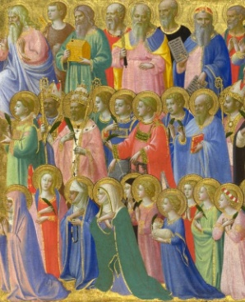
Today
Sung Eucharist
followed by refreshments in the Hall

August

Mon | 19
Tues | 20 | 10am Prayer Group
Wed | 21
Thurs | 22 | 10am said Holy Communion followed by coffee in Friendship House
Fri | 23
Sat | 24
Sun | 25 | 10am Sung Eucharist followed by Coffee and Talent Auction!
Sat | 31 | 11am Cake walk followed by tea at 3pm in hall

A WARM WELCOME IS EXTENDED TO ALL VISITORS. PLEASE SIGN THE VISITORS BOOK AT THE BACK OF THE CHURCH. WE'D BE GRATEFUL, TOO, IF YOU WOULD GIFT-AID ANY OFFERING. ASK THE PERSON WHO HANDED YOU THIS FOR A GIFT AID ENVELOPE. THANK YOU.

EVERYONE IS INVITED TO TEA & COFFEE IN THE HALL AFTER THIS SERVICE

if anyone wishes a visit from a priest, please contact ANDREA HAGENBUCH,

0141 942 0029

