Next Sunday – 18th August 9th Sunday after Trinity

Sunday Eucharists – Prayer and healing ministry is now routinely available during Communion at the back of the church

Talent Auction on Sunday 18th August
NEXT SUNDAY!!!!!
The auction will take place after church/coffee on the 18^{th.}
Please do support!! It was a great success last time and led to a lot of fun and enjoyment plus raised much needed funds.

Dorcas Craft Group
Saturday 17th August 11- 3pm in the Hall – All welcome.

Fundraising
St. Andrew's 'Blessings Box' is now in operation.
Take a box home, consume the contents, fill with coins, bring back to church for Gail, who will then empty it, refill with jelly beans, and return it to you!

PLEASE PASS INFORMATION FOR NOTICES TO Andrea BY THE THURSDAY OF ANY WEEk
Tel: 0141 942 0029 Email: andreahagenbuch@outlook.com

St Andrew’s  Scottish Episcopal Church,  Park Road, Milngavie  Sunday 11th August  8th Sunday after Trinity |  |  | 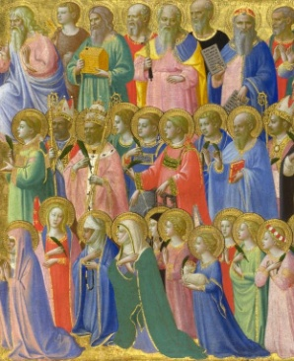
Today
Sung Eucharist
followed by refreshments in the Hall

August

Mon | 12 | 7.30 Vestry
Tues | 13 | 10am Prayer Group
Wed | 14
Thurs | 15 | 10am said Holy Communion followed by coffee in Friendship House
Fri | 16
Sat | 17 | 11-3pm Dorcas Craft Group - Hall
Sun | 18 | 10am Sung Eucharist

A WARM WELCOME IS EXTENDED TO ALL VISITORS. PLEASE SIGN THE VISITORS BOOK AT THE BACK OF THE CHURCH. WE'D BE GRATEFUL, TOO, IF YOU WOULD GIFT-AID ANY OFFERING. ASK THE PERSON WHO HANDED YOU THIS FOR A GIFT AID ENVELOPE. THANK YOU.

EVERYONE IS INVITED TO TEA & COFFEE IN THE HALL AFTER THIS SERVICE

if anyone wishes a visit from a priest, please contact ANDREA HAGENBUCH,

0141 942 0029

