Next Sunday – 11th August 8th Sunday after Trinity

Sunday Eucharists – Prayer and healing ministry is now routinely available during Communion at the back of the church

Talent Auction on Sunday 18th August
Angela is now taking final orders for 'talents' that can be offered and 'wishes' for services/walks/training/days out that might be fulfilled.
The auction will take place after church/coffee on the 18^{th.}
Please do support!! It was a great success last time and led to a lot of fun and enjoyment plus raised much needed funds.

North West Regional Council Outing to Dunblane.
Sunday 11th August – All welcome
The programme is to take packed lunches to St Mary's hall any time after 12.30. We can then explore the town and cathedral. It is St Blane's day so we can join in an ecumenical pilgrim walk around the churches which starts at 3.0, finishing at 4.30 - 5.0 with afternoon tea in the church hall. There is also an exhibition to celebrate 130 years of the Mothers Union in Scotland, the first branch being in Dunblane. Please let Tim or me know if you would like to come – lifts available.

Fundraising
St. Andrew's 'Blessings Box' is now in operation.
Take a box home, consume the contents, fill with coins, bring back to church for Gail, who will then empty it, refill with jelly beans, and return it to you!

PLEASE PASS INFORMATION FOR NOTICES TO Andrea BY THE THURSDAY OF ANY WEEk
Tel: 0141 942 0029 Email: andreahagenbuch@outlook.com

St Andrew’s  Scottish Episcopal Church,  Park Road, Milngavie  Sunday 4th August  Seventh Sunday after Trinity |  |  | 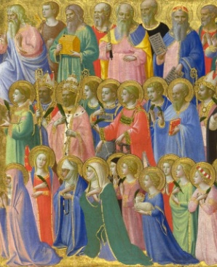
Today
Sung Eucharist
followed by refreshments in the Hall

August

Mon | 5
Tues | 6 | 10am Prayer Group
Wed | 7
Thurs | 8 | 10am said Holy Communion followed by coffee in Friendship House
Fri | 9
Sat | 10
Sun | 11 | 10am Sung Eucharist  NWR Outing to Dunblane

A WARM WELCOME IS EXTENDED TO ALL VISITORS. PLEASE SIGN THE VISITORS BOOK AT THE BACK OF THE CHURCH. WE'D BE GRATEFUL, TOO, IF YOU WOULD GIFT-AID ANY OFFERING. ASK THE PERSON WHO HANDED YOU THIS FOR A GIFT AID ENVELOPE. THANK YOU.

EVERYONE IS INVITED TO TEA & COFFEE IN THE HALL AFTER THIS SERVICE

if anyone wishes a visit from a priest, please contact ANDREA HAGENBUCH,

0141 942 0029

