Next Sunday – 6th October 16th Sunday after Trinity

Sunday Eucharists – Prayer and healing ministry is now routinely available during Communion at the back of the church

Favourite Hymn Requests
There is a list at the back of the church for your favourite hymns.
So far, we have a few requests!
Please feel free to add some more – the organist is very keen to hear from you!

Thursday 3rd October 6-7.30pm Paisley Maclean Building
High Street Paisley PA1 2BE
Lecture –“ What is Truth and Why it Matters Today More Than Ever” given by David Gushee

Sunday 20th October
AGM after the service – please can you have relevant reports ready and a copy sent to Angela.

Saturday 12th October
Labyrinth – official opening
10.30 Lennox park followed by coffee in Gavin’s Mill. All very welcome.

PLEASE PASS INFORMATION FOR NOTICES TO Andrea BY THE THURSDAY OF ANY WEEk
Tel: 0141 942 0029 Email: andreahagenbuch@outlook.com

St Andrew’s  Scottish Episcopal Church,  Park Road, Milngavie  Sunday 29th September  St Michael and All Angels |  |  | 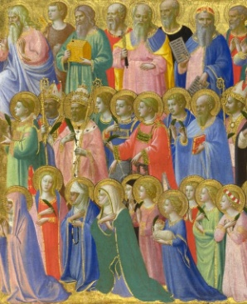
Today
Sung Eucharist
followed by refreshments in the Hall

October

Mon | 30
Tues | 1 | 10am Prayer Group
Wed | 2
Thurs | 3 | 10am said Holy Communion followed by coffee in Friendship House
Fri | 4
Sat | 5
Sun | 6 | 10am Sung Eucharist followed by Coffee in Hall

A WARM WELCOME IS EXTENDED TO ALL VISITORS. PLEASE SIGN THE VISITORS BOOK AT THE BACK OF THE CHURCH. WE'D BE GRATEFUL, TOO, IF YOU WOULD GIFT-AID ANY OFFERING. ASK THE PERSON WHO HANDED YOU THIS FOR A GIFT AID ENVELOPE. THANK YOU.

EVERYONE IS INVITED TO TEA & COFFEE IN THE HALL AFTER THIS SERVICE

if anyone wishes a visit from a priest, please contact ANDREA HAGENBUCH,

0141 942 0029

