Next Sunday – 29th September 15th Sunday after Trinity

Sunday Eucharists – Prayer and healing ministry is now routinely available during Communion at the back of the church

Favourite Hymn Requests
There is a list at the back of the church for your favourite hymns.
So far, we have only two such requests!
Please feel free to add some more – the organist is very keen to hear from you!

Sunday 29th September
Farewell lunch for Liz and George

Thursday 26th September
Fellowship outing to Helensburgh.
Includes lunch and trip to Helensburgh submarine museum.

PLEASE PASS INFORMATION FOR NOTICES TO Andrea BY THE THURSDAY OF ANY WEEk
Tel: 0141 942 0029 Email: andreahagenbuch@outlook.com

St Andrew’s  Scottish Episcopal Church,  Park Road, Milngavie  Sunday 22nd September  14th Sunday after Trinity |  |  | 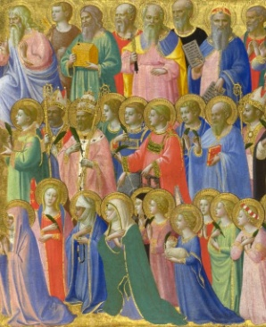
Today
Sung Eucharist
followed by refreshments in the Hall

September

Mon | 23 | 7.30 Vestry
Tues | 24 | 10am Prayer Group
Wed | 25
Thurs | 26 | 10am said Holy Communion followed by coffee in Friendship House and outing to Helensburgh
Fri | 27
Sat | 28
Sun | 29 | 10am Sung Eucharist followed by Coffee in Hall  Lunch for George and Liz’s Farewell

A WARM WELCOME IS EXTENDED TO ALL VISITORS. PLEASE SIGN THE VISITORS BOOK AT THE BACK OF THE CHURCH. WE'D BE GRATEFUL, TOO, IF YOU WOULD GIFT-AID ANY OFFERING. ASK THE PERSON WHO HANDED YOU THIS FOR A GIFT AID ENVELOPE. THANK YOU.

EVERYONE IS INVITED TO TEA & COFFEE IN THE HALL AFTER THIS SERVICE

if anyone wishes a visit from a priest, please contact ANDREA HAGENBUCH,

0141 942 0029

