Next Sunday – 13th October 17th Sunday after Trinity - Harvest

Sunday Eucharists – Prayer and healing ministry is now routinely available during Communion at the back of the church

Favourite Hymn Requests
There is a list at the back of the church for your favourite hymns.
So far, we have a few requests!
Please feel free to add some more – the organist is very keen to hear from you!

Sunday 20th October
AGM after the service – please can you have relevant reports ready and a copy sent to Angela. Any matters of AOCB need to be sent to Angela also, asap.

Saturday 12th October
Labyrinth – official opening
10.30 Lennox park followed by coffee in Gavin’s Mill. All very welcome.

Bible Study – Brocken – TV Drama Series
Starts here Wednesday 23th October alt weeks for six weeks
At St Andrew’s, Bishopbriggs and All Saints.
Please let me know if you are interested.

PLEASE PASS INFORMATION FOR NOTICES TO Andrea BY THE THURSDAY OF ANY WEEk
Tel: 0141 942 0029 Email: andreahagenbuch@outlook.com

St Andrew’s  Scottish Episcopal Church,  Park Road, Milngavie  Sunday 6th October  16th Sunday after Trinity |  |  | 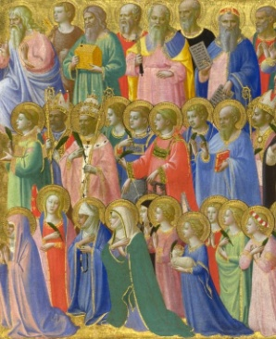
Today
Sung Eucharist
followed by refreshments in the Hall

October

Mon | 7
Tues | 8 | 10am Prayer Group
Wed | 9 | 7.30 Book Group – Helen’s
Thurs | 10 | 10am said Holy Communion followed by coffee in Friendship House
Fri | 11
Sat | 12 | 10.30 Labyrinth Opening Lennox Park
Sun | 13 | 10am Sung Eucharist for Harvest followed by Coffee in Hall

A WARM WELCOME IS EXTENDED TO ALL VISITORS. PLEASE SIGN THE VISITORS BOOK AT THE BACK OF THE CHURCH. WE'D BE GRATEFUL, TOO, IF YOU WOULD GIFT-AID ANY OFFERING. ASK THE PERSON WHO HANDED YOU THIS FOR A GIFT AID ENVELOPE. THANK YOU.

EVERYONE IS INVITED TO TEA & COFFEE IN THE HALL AFTER THIS SERVICE

if anyone wishes a visit from a priest, please contact ANDREA HAGENBUCH,

0141 942 0029

