Next Sunday – 3rd November All Saints Day

Favourite Hymn Requests
There is a list at the back of the church for your favourite hymns.

Saturday 9th November 10-12pm Church Coffee Morning

Milngavie Choir - A concert of Remembrance at St Andrew’s
Friday 8th November 8- 9pm
Sunday 10th November 3-4pm
Tickets available in advance or on the door

Bible Study – Brocken – TV Drama Series with St Andrew’s, Bishopbriggs and All Saints.
Every Wednesday 7 for 7.15pm.
This Wednesday All Saints - All Welcome

Message from Liz:
Care4Calais – provides aid to refugees and asylum seekers in the north of France who are constantly being moved on by the police, with their sleeping bags and possessions confiscated. There will be a van travelling to France in November from Rhu. If anyone has any unwanted sleeping bags, tents or blankets please let Liz Macdonald know. If anyone would like to make a donation this would also be welcome as it helps the organisation provide other items such as underwear or toiletries.

Message from Tim - Milngavie in Bloom Calendars and Cards.
Please see Tim if you would like any- 7 pounds per calendar and 2.50 for pack of five cards.

PLEASE PASS INFORMATION FOR NOTICES TO Andrea BY THE THURSDAY OF ANY WEEk
Tel: 0141 942 0029 Email: andreahagenbuch@outlook.com

St Andrew’s  Scottish Episcopal Church,  Park Road, Milngavie  Sunday 27th October  Last Sunday after Trinity  Bible Sunday |  |  | 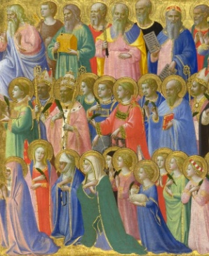
Today
Sung Eucharist
followed by refreshments in the Hall

October |  | Prayer and Healing ministry available during Communion at the back of the church
Mon | 28
Tues | 29 | 10am Prayer Group
Wed | 30 | 7 for 7.15pm Bible Study – All Saints
Thurs | 31 | 10am said Holy Communion followed by coffee in Friendship House
Fri | 1
Sat | 2
Sun | 3 | 10am Sung Eucharist followed by Coffee in Hall

A WARM WELCOME IS EXTENDED TO ALL VISITORS. PLEASE SIGN THE VISITORS BOOK AT THE BACK OF THE CHURCH. WE'D BE GRATEFUL, TOO, IF YOU WOULD GIFT-AID ANY OFFERING. ASK THE PERSON WHO HANDED YOU THIS FOR A GIFT AID ENVELOPE. THANK YOU.

EVERYONE IS INVITED TO TEA & COFFEE IN THE HALL AFTER THIS SERVICE

if anyone wishes a visit from a priest, please contact ANDREA HAGENBUCH,

0141 942 0029

