Next Sunday – 27th October - Last Sunday after Trinity – Bible Sunday

Sunday Eucharists – Prayer and healing ministry is now routinely available during Communion at the back of the church

Favourite Hymn Requests
There is a list at the back of the church for your favourite hymns.
So far, we have a few requests!
Please feel free to add some more – the organist is very keen to hear from you!

Sunday 20th October
AGM after the service – TODAY!!!!

Bible Study – Broken – TV Drama Series with St Andrew’s, Bishopbriggs and All Saints.
Starts here this Wednesday 23th October for six weeks
7 for 7.15pm.
Please let me know if you are interested.

Message from Liz:
Care4Calais – provides aid to refugees and asylum seekers in the north of France who are constantly being moved on by the police, with their sleeping bags and possessions confiscated. There will be a van travelling to France in November from Rhu. If anyone has any unwanted sleeping bags, tents or blankets please let Liz Macdonald know. If anyone would like to make a donation this would also be welcome as it helps the organisation provide other items such as underwear or toiletries.

PLEASE PASS INFORMATION FOR NOTICES TO Andrea BY THE THURSDAY OF ANY WEEK
Tel: 0141 942 0029 Email: andreahagenbuch@outlook.com

St Andrew’s  Scottish Episcopal Church,  Park Road, Milngavie  Sunday 20th October  18th Sunday after Trinity  AGM |  |  | 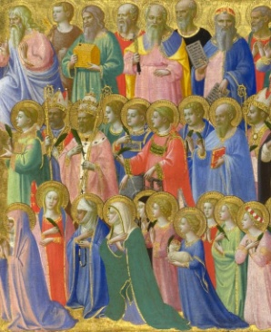
Today
Sung Eucharist
followed by refreshments in the Hall

October

Mon | 21 | 7.30 Choir Practice
Tues | 22 | 10am Prayer Group
Wed | 23 | 7 for 7.15pm Bible Study in Church
Thurs | 24 | 10am said Holy Communion followed by coffee in Friendship House
Fri | 25
Sat | 26
Sun | 27 | 10am Sung Eucharist followed by Coffee in Hall

A WARM WELCOME IS EXTENDED TO ALL VISITORS. PLEASE SIGN THE VISITORS BOOK AT THE BACK OF THE CHURCH. WE'D BE GRATEFUL, TOO, IF YOU WOULD GIFT-AID ANY OFFERING. ASK THE PERSON WHO HANDED YOU THIS FOR A GIFT AID ENVELOPE. THANK YOU.

EVERYONE IS INVITED TO TEA & COFFEE IN THE HALL AFTER THIS SERVICE

if anyone wishes a visit from a priest, please contact ANDREA HAGENBUCH,

0141 942 0029

