Next Sunday – 10th November - Remembrance Sunday
Favourite Hymn Requests
There is a list at the back of the church for your favourite hymns.

Patronal Eucharist – Friday 29th November 7pm followed by Fish and Chips in the hall. Numbers for supper please to Pamela.
Preacher – Fraser Gold

Christmas Lunch – Saturday 14th December 12 for 12.30pm in the hall. Please let me or Claire know if you would like a ticket.

Bible Study – Brocken – TV Drama Series with St Andrew’s, Bishopbriggs and All Saints.
Every Wednesday 7 for 7.15pm.
This Wednesday - Bishopbriggs – last one.

Milngavie United Free Church - Friday 6 December at 7.30pm.
An evening with Ian White.
Ian is a Christian musician who has recorded many top selling albums and travelled and performed internationally for more than 25 years. During the evening Ian will sing, lead some congregational singing and speak of his work with disabled people in the Inspiration Orchestra. This event is free and donations will be received for the Inspiration Orchestra.

Message from Tim - Milngavie in Bloom Calendars and Cards.
Please see Tim if you would like any- 7 pounds per calendar and 2.50 for pack of five cards.

PLEASE PASS INFORMATION FOR NOTICES TO Andrea BY THE THURSDAY OF ANY WEEk
Tel: 0141 942 0029 Email: andreahagenbuch@outlook.com

St Andrew’s  Scottish Episcopal Church,  Park Road, Milngavie  Sunday 24th November  Christ The king |  |  | 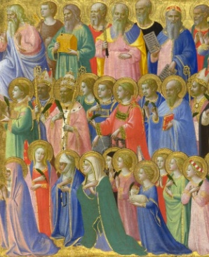
Today
Sung Eucharist
followed by refreshments in the Hall

November |  | Prayer and Healing ministry available during Communion at the back of the church
Mon | 25 | 7.30 Choir rehearsal
Tues | 26 | 10am Prayer Group
Wed | 27 | 7 for 7.15pm Bible Study – Bishopbriggs  7.30pm Book Group – Caroline’s
Thurs | 28 | 10am said Holy Communion followed by coffee in Friendship House
Fri | 29 | 7pm Patronal Eucharist followed by F and Cs in hall.
Sat | 30
Sun | 1 | Sung Eucharist for Advent Sunday followed by coffee in hall.

A WARM WELCOME IS EXTENDED TO ALL VISITORS. PLEASE SIGN THE VISITORS BOOK AT THE BACK OF THE CHURCH. WE'D BE GRATEFUL, TOO, IF YOU WOULD GIFT-AID ANY OFFERING. ASK THE PERSON WHO HANDED YOU THIS FOR A GIFT AID ENVELOPE. THANK YOU.

EVERYONE IS INVITED TO TEA & COFFEE IN THE HALL AFTER THIS SERVICE

if anyone wishes a visit from a priest, please contact ANDREA HAGENBUCH,

0141 942 0029

