Next Sunday – 10th November - Remembrance Sunday

Favourite Hymn Requests
There is a list at the back of the church for your favourite hymns.

Fair Trade Talk – This pm at Gavin’s Mill £6 2-4pm

Saturday 9th November 10-12pm Church Coffee Morning!!!!!

Milngavie Choir - A concert of Remembrance at St Andrew’s
Friday 8th November 8- 9pm
Sunday 10th November 3-4pm
Tickets available in advance or on the door

Bible Study – Broken – TV Drama Series with St Andrew’s, Bishopbriggs and All Saints. Every Wednesday 7 for 7.15pm.
This Wednesday - Bishopbriggs

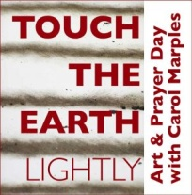
Touch The Earth Lightly
An Art and Prayer Workshop Day led by Carol Marples, Sat Nov 9th 10am-4pm Iona Community, 21 Carlton Court, Glasgow G5 9JP https://www.wildgoose.scot/event/touch-the-earth-lightly/

Message from Liz:
Care4Calais – provides aid to refugees and asylum seekers in the north of France who are constantly being moved on by the police, If anyone has any unwanted sleeping bags, tents or blankets please let Liz Macdonald know. If anyone would like to make a donation this would also be welcome.

Message from Tim - Milngavie in Bloom Calendars and Cards.
Please see Tim if you would like any- 7 pounds per calendar and 2.50 for pack of five cards.

St Andrew’s  Scottish Episcopal Church,  Park Road, Milngavie  Sunday 3rd November  All Saints Day |  |  | 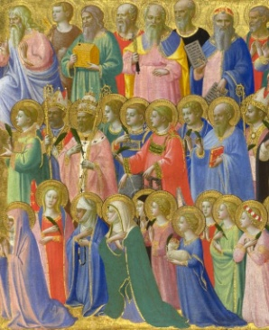
Today
Sung Eucharist
followed by refreshments in the Hall

October |  | Prayer and Healing ministry available during Communion at the back of the church
Mon | 4 | 7.30pm Vestry meeting
Tues | 5 | 10am Prayer Group
Wed | 6 | 7 for 7.15pm Bible Study – Bishopbriggs
Thurs | 7 | 10am said Holy Communion followed by coffee in Friendship House
Fri | 8 | 8-9pm Milngavie Choir Concert of Remembrance
Sat | 9 | 10am-12noon Church Coffee Morning in hall
Sun | 10 | 10am Sung Eucharist followed by Coffee in Hall  11am Act of Remembrance in Precinct

A WARM WELCOME IS EXTENDED TO ALL VISITORS. PLEASE SIGN THE VISITORS BOOK AT THE BACK OF THE CHURCH. WE'D BE GRATEFUL, TOO, IF YOU WOULD GIFT-AID ANY OFFERING. ASK THE PERSON WHO HANDED YOU THIS FOR A GIFT AID ENVELOPE. THANK YOU.

EVERYONE IS INVITED TO TEA & COFFEE IN THE HALL AFTER THIS SERVICE

if anyone wishes a visit from a priest, please contact ANDREA HAGENBUCH,

0141 942 0029

PLEASE PASS INFORMATION FOR NOTICES TO Andrea BY THE THURSDAY
OF ANY WEEK Tel: 0141 942 0029 Email: andreahagenbuch@outlook.com

