Next Sunday – 8th December – 2nd Sunday in Advent.

Christmas Lunch – Saturday 14th December 12 for 12.30pm in the hall. Please let me or Claire know if you would like a ticket.

Milngavie United Free Church - Friday 6 December at 7.30pm.
An evening with Ian White.
Ian is a Christian musician who has recorded many top selling albums and travelled and performed internationally for more than 25 years. During the evening Ian will sing, lead some congregational singing and speak of his work with disabled people in the Inspiration Orchestra. This event is free and donations will be received for the Inspiration Orchestra.

Message from Tim - Milngavie in Bloom Calendars.
Please see Tim if you would like any- £7 per calendar.

PLEASE PASS INFORMATION FOR NOTICES TO Andrea BY THE THURSDAY OF ANY WEEk
Tel: 0141 942 0029 Email: andreahagenbuch@outlook.com

St Andrew’s  Scottish Episcopal Church,  Park Road, Milngavie  Sunday 1st December  Advent Sunday |  |  | 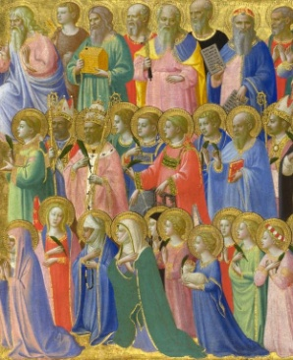
Today
Sung Eucharist
followed by refreshments in the Hall

December |  | Prayer and Healing ministry available during Communion at the back of the church
Mon | 2
Tues | 3 | 10am Prayer Group
Wed | 4
Thurs | 5 | 10am said Holy Communion followed by coffee in Friendship House
Fri | 6
Sat | 7
Sun | 8 | Sung Eucharist followed by coffee in hall.

A WARM WELCOME IS EXTENDED TO ALL VISITORS. PLEASE SIGN THE VISITORS BOOK AT THE BACK OF THE CHURCH. WE'D BE GRATEFUL, TOO, IF YOU WOULD GIFT-AID ANY OFFERING. ASK THE PERSON WHO HANDED YOU THIS FOR A GIFT AID ENVELOPE. THANK YOU.

EVERYONE IS INVITED TO TEA & COFFEE IN THE HALL AFTER THIS SERVICE

if anyone wishes a visit from a priest, please contact ANDREA HAGENBUCH,

0141 942 0029

