Next Sunday – 15th March 3rd Sunday of Lent

Wednesday 18th March 7 for 7.30pm in Church
A talk for Lent by Debbie Lewer – Art Historian at Glasgow University. “Meeting Judas through Art”
All welcome to this!! Debbie is an excellent speaker.

7.30pm Wednesday 11th March - Ignatius Reflection in Church
Led by Stephen Parrot
Based on our Lent book – an hour of sharing and reflection – highly recommended!

Corona Virus!
It has been decided, in order to minimise the risk of infection, we will not longer, for the time being, share the peace or the chalice.
Holy Communion will be received in one kind ie wafer only. It is also recommended standing at the alter rather than kneeling as this reduces the risk of spread through touching the rail.

PLEASE PASS INFORMATION FOR NOTICES TO Andrea BY THE THURSDAY OF ANY WEEk
Tel: 0141 942 0029 Email: andreahagenbuch@outlook.com

St Andrew’s  Scottish Episcopal Church,  Park Road, Milngavie  Sunday 8th March  2nd Sunday of Lent |  |  | 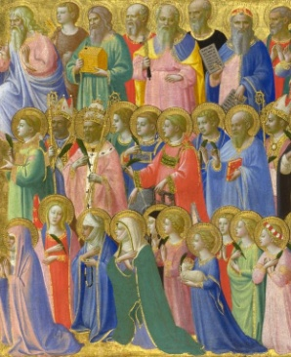
Today
Sung Eucharist
followed by refreshments in the Hall

March |  | Prayer and Healing ministry available during Communion at the back of the church
Mon | 9
Tues | 10 | 10am Prayer Group
Wed | 11 | 7.30pm Book Group – Angela  7.30pm Ignatius Reflection in Church
Thurs | 12 | 10am Said Holy Communion followed by coffee in Friendship House
Fri | 13
Sat | 14
Sun | 15 | 10am Sung Eucharist followed by coffee in hall.

A WARM WELCOME IS EXTENDED TO ALL VISITORS. PLEASE SIGN THE VISITORS BOOK AT THE BACK OF THE CHURCH. WE'D BE GRATEFUL, TOO, IF YOU WOULD GIFT-AID ANY OFFERING. ASK THE PERSON WHO HANDED YOU THIS FOR A GIFT AID ENVELOPE. THANK YOU.

EVERYONE IS INVITED TO TEA & COFFEE IN THE HALL AFTER THIS SERVICE

if anyone wishes a visit from a priest, please contact ANDREA HAGENBUCH,

0141 942 0029

