Next Sunday – 22nd March 4th Sunday of Lent – Mothering Sunday

The talk by Debbie Lewer planned for Wednesday 18th March
“Meeting Judas through Art” has now been CANCELLED!!

6.30pm Special Choral Evensong in St Mary’s Cathedral to welcome The Very Rev Ian Barcroft and Rev Cedric Blakely as Honorary Canons. Singers from St Andrew’s have been invited to join the choir. All welcome

Corona Virus!
It has been decided, in order to minimise the risk of infection, we will not longer, for the time being, share the peace or the chalice.
Holy Communion will be received in one kind ie wafer only. It is also recommended standing at the alter rather than kneeling as this reduces the risk of spread through touching the rail.

Update!
Friendship house will close from Monday16th.

Thursdays Said Holy Communions will now cease until further notice.

Sunday services will continue to take place, but coffee will not be served afterwards.

From March 22nd Scottish Episcopal Church is planning to broadcast worship online – more details next week

PLEASE PASS INFORMATION FOR NOTICES TO Andrea BY THE THURSDAY OF ANY WEEk
Tel: 0141 942 0029 Email: andreahagenbuch@outlook.com

St Andrew’s  Scottish Episcopal Church,  Park Road, Milngavie  Sunday 15th March  3rd Sunday of Lent |  |  | 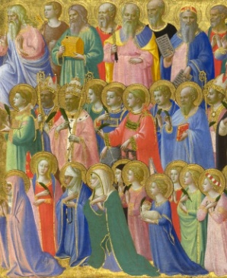
Today
Sung Eucharist
followed by refreshments in the Hall

March |  | Prayer and Healing ministry available during Communion at the back of the church
Mon | 16
Tues | 17 | 10am Prayer Group
Wed | 18 | 7.30pm Ignatius reflection in Church
Thurs | 19 | No Holy Communion – due to the Corona Virus Thursday services are suspended for the duration.
Fri | 20
Sat | 21
Sun | 22 | 10am Sung Eucharist.  6.30pm Choral Evensong in St Mary’s Cathedral

A WARM WELCOME IS EXTENDED TO ALL VISITORS. PLEASE SIGN THE VISITORS BOOK AT THE BACK OF THE CHURCH. WE'D BE GRATEFUL, TOO, IF YOU WOULD GIFT-AID ANY OFFERING. ASK THE PERSON WHO HANDED YOU THIS FOR A GIFT AID ENVELOPE. THANK YOU.

EVERYONE IS INVITED TO TEA & COFFEE IN THE HALL AFTER THIS SERVICE

if anyone wishes a visit from a priest, please contact ANDREA HAGENBUCH,

0141 942 0029

